**How do I apply for Pennsylvania Child Abuse Clearance On-line?**

There are two sets of clearances required as a volunteer. These instructions will help you apply for both of them.

II. Pennsylvania Child Abuse Clearances On-line:

1) Type the state police web link into your web browser:

<https://www.compass.state.pa.us/cwis/public/home>

2) The screen you come to will look like this:

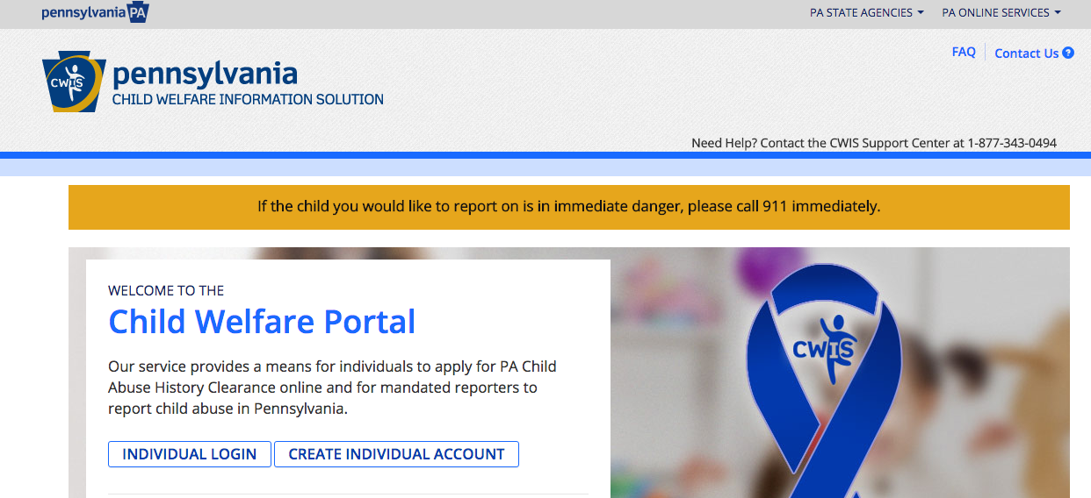

Click on the box that says “Create Individual Account

3) The next screen you see will look like this:

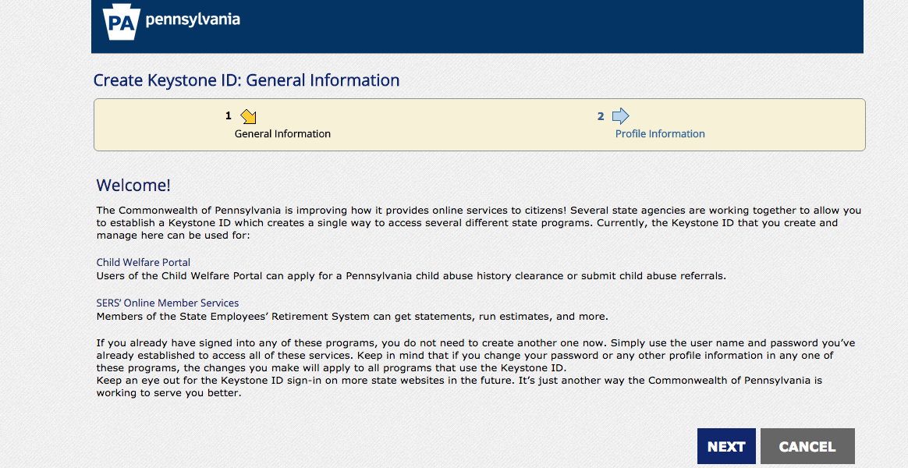

Read through the terms and conditions. If you agree to the terms and conditions, scroll to the bottom of the screen.

4) On the next screen you will need to enter information.

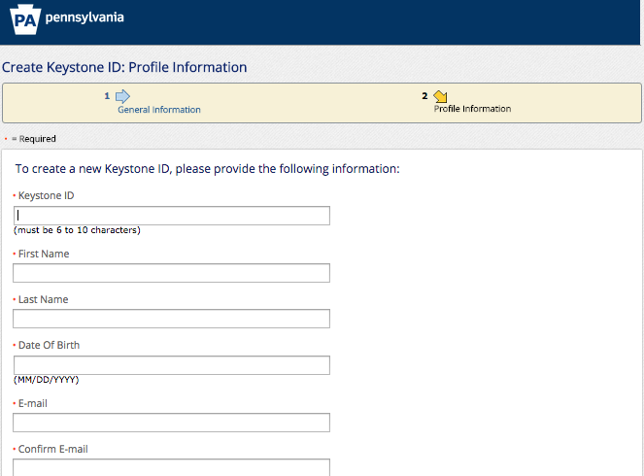

You will need to create an ID. For example, my ID was FRodrigo- First initial, last name.

Continue to enter your Name, Date of Birth, and email.

5) Continue to enter the information being requested.

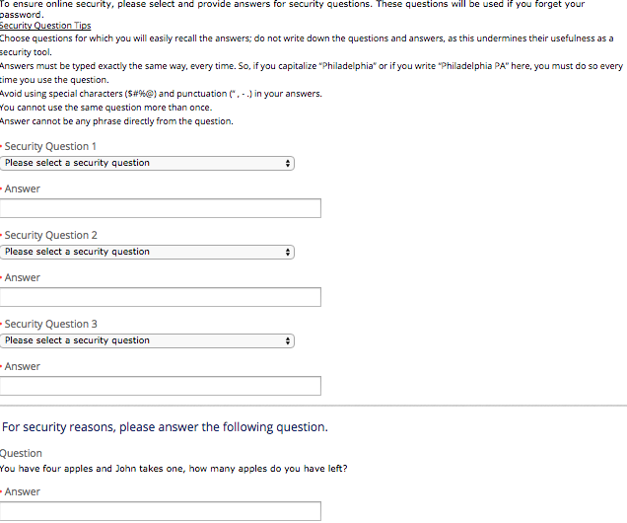

Choose your personal security question. Type the answer in the box below it. Do this for all 3 security questions.

Type the answer the next question you see on the screen into the box

underneath the question. **Then hit submit.**

6) You will need to check the email account you entered into the website with the rest of your information. You will receive **two emails,** the second will contain a temporary password. The email may look like this.

**Email 1: Contains your user ID you set up**

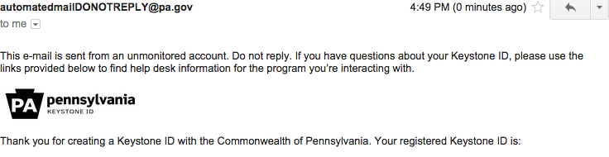

**Email 2: Contains your temporary password.**

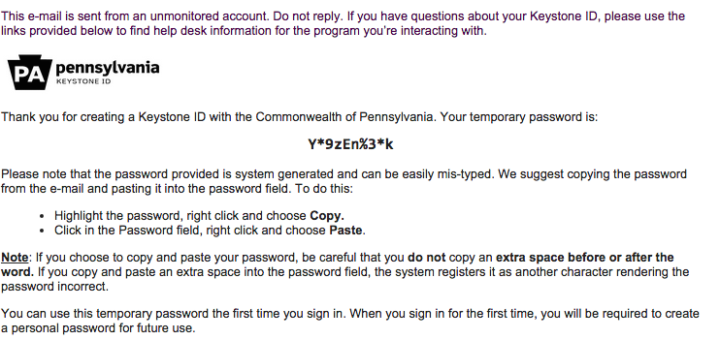

Highlight the temporary password and hit “control” button and “C” button at the same time.

7) Return the main website again: <https://www.compass.state.pa.us/cwis/public/home>

8) The screen will look the same as when you started.

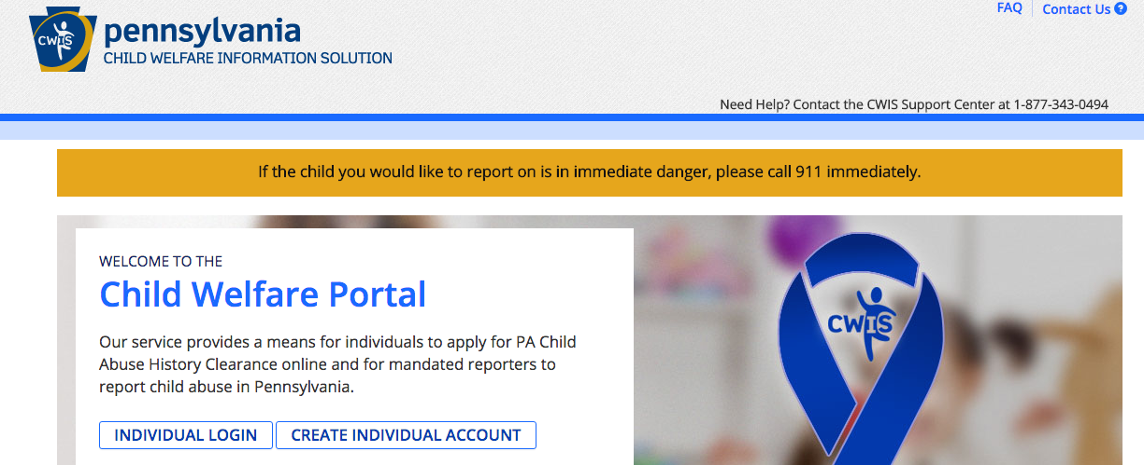

This time, click on

**“Individual Login”**

9) On this screen, click on **“Access My Clearances”** in the middle of the screen.

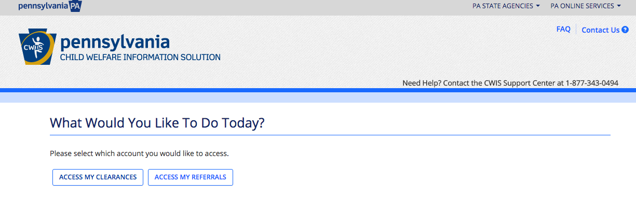

10) Read through the information on the next page.

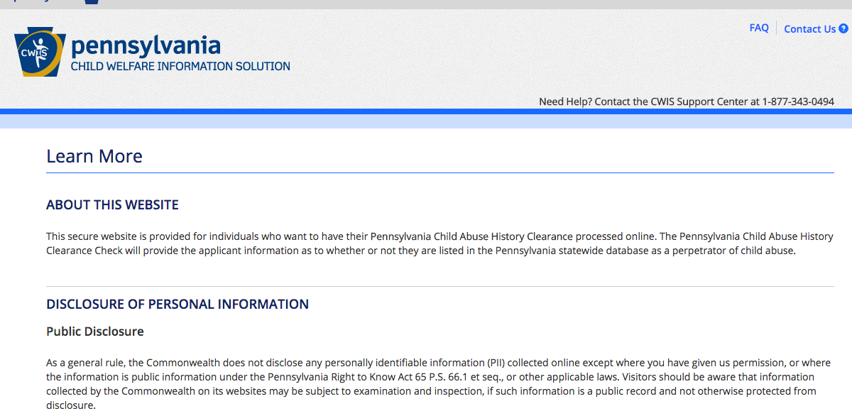

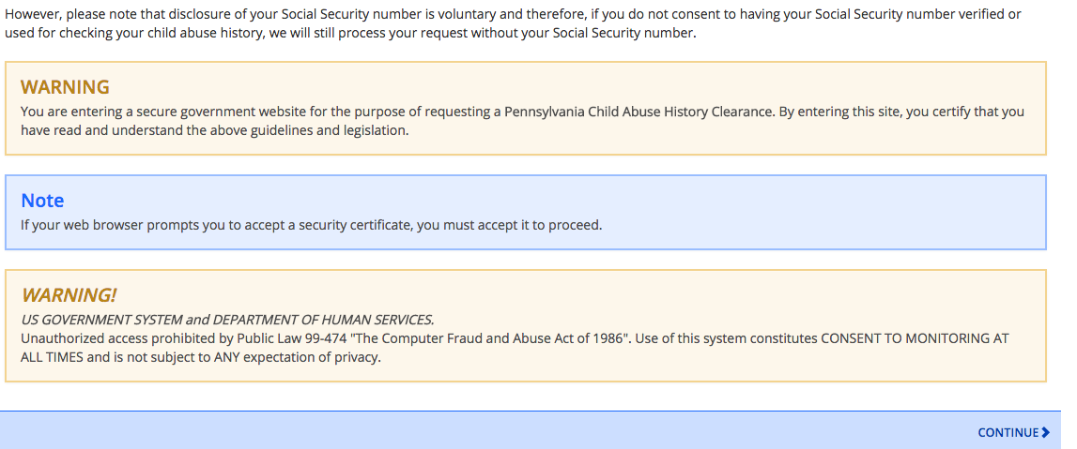

Then click **“continue”**

11) You will now have to enter the login ID you created and the temporary password.

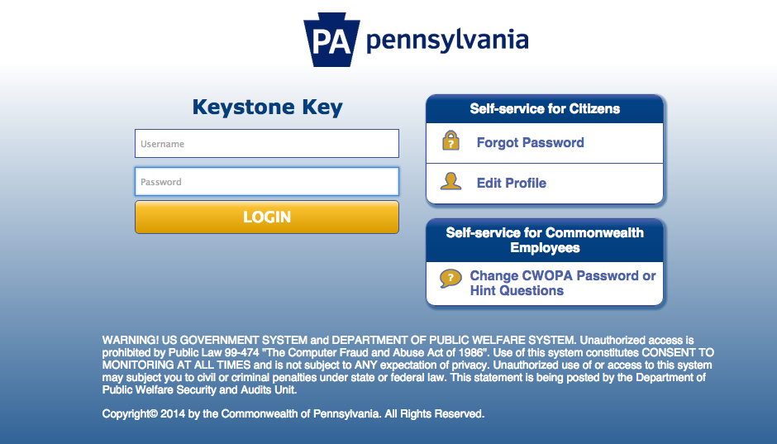

After you type in your ID,

Click on the box for the password.

**Then hit “control” button and**

**“v” at the same time.** Your

temporary password will be

pasted in the box.

Then click on the yellow “LOGIN” box.

12) You will be prompted to set a new password.

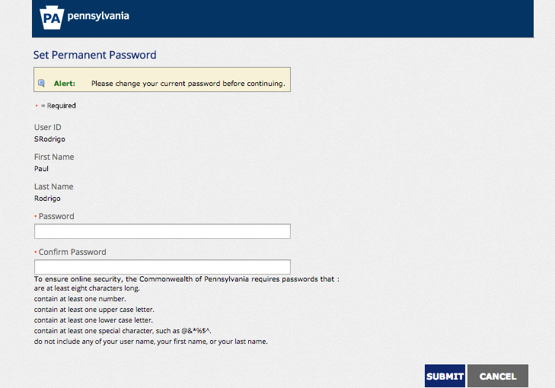

Once you’ve chosen a password, click the dark blue submit button.

13) You will see this screen next. Click **“Close”**

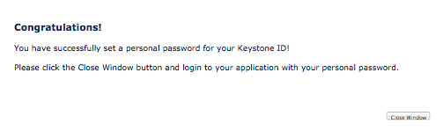

14) Your next screen will contain the “Terms

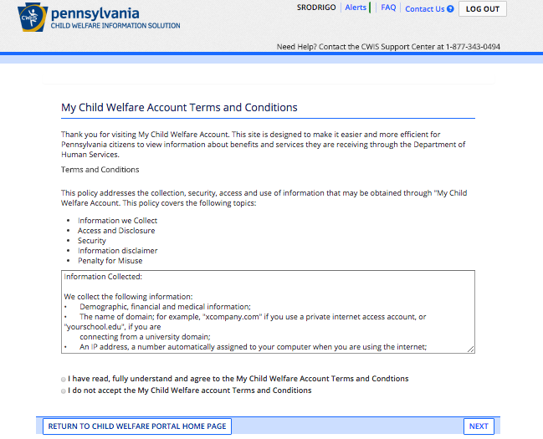and Conditions.”

Read the terms. If you accept the terms click

the first circle indicating you accept the terms.

Then click “NEXT”

15) The next page contains more information for you to review.

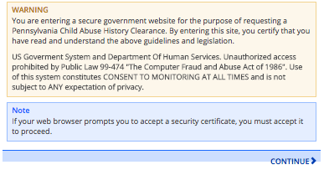

Click continue at the bottom of the page

16) Click on **“Create Clearance Application”** 17) Click **“begin”**

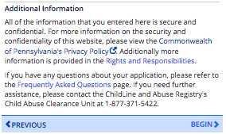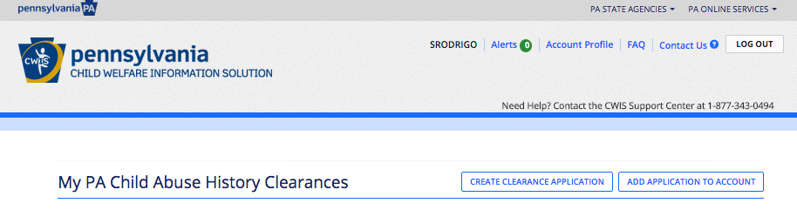

19) Complete the “Application Purpose” Page.

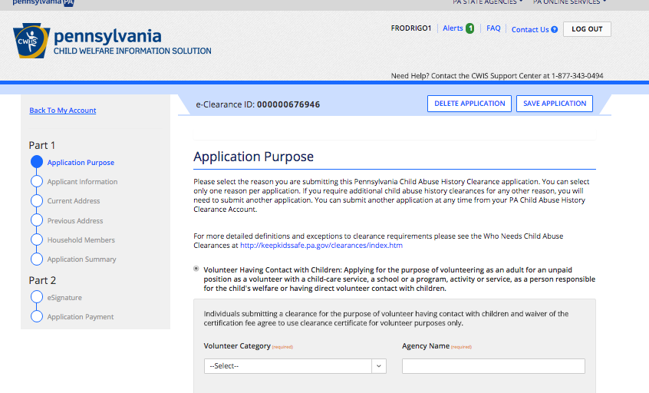

Make sure the “volunteer”

bubble is filled.

Then select “Other” for the

institution you are volunteering,

unless you see your option in the

drop-down menu.

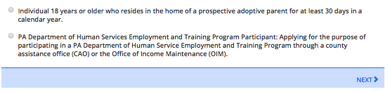

At the bottom of the page click “NEXT”

20) Enter your information into the next page. You will need to enter your name, birthday and social security number, and email address.

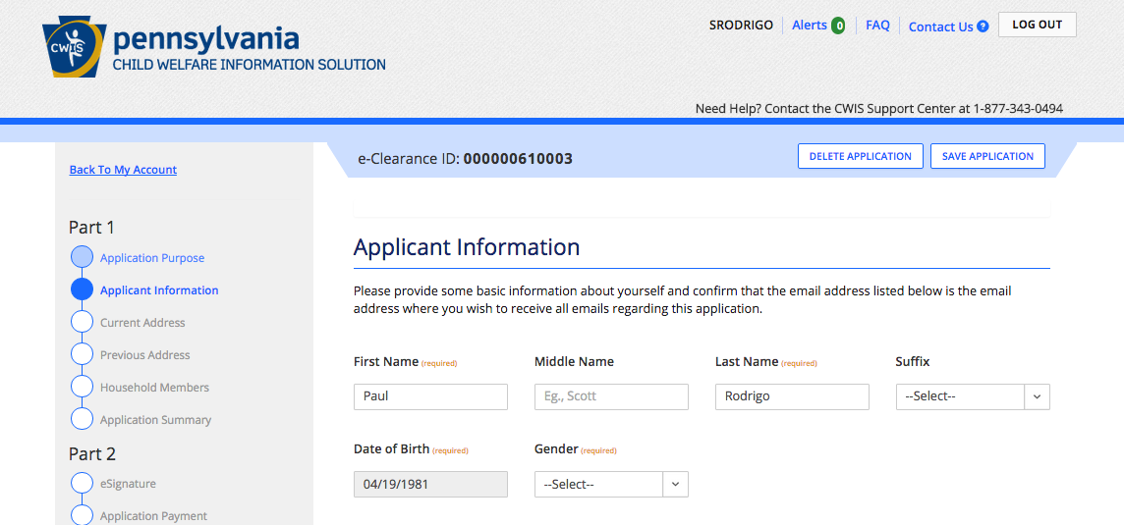

After you enter your email address, you will be asked if you have used any previous names in the past. **If you have not, click no. If you have been married, changed your last name for adoption purposes, etc. Click Yes.**

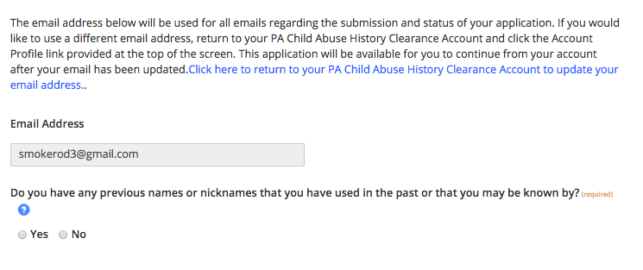

**If you clicked “NO” skip to step # 22!!**

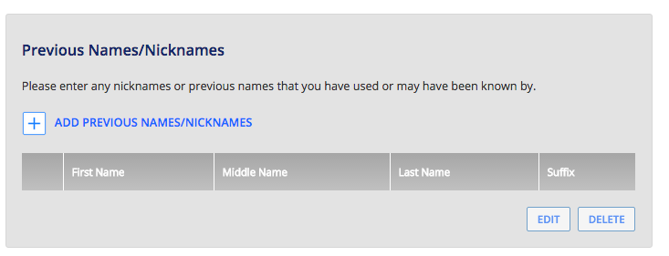

If you clicked yes, you will see a “+” sign

on this page. Click it and add the your

previous names.

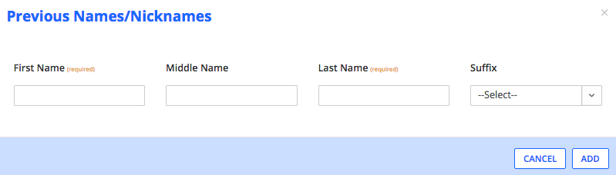

After you add your names each time, click “ADD”

Keep clicking the “+” sign until you’ve added and see all of your previous names listed.

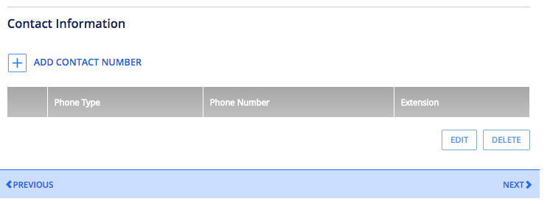22) Then click the “+” to add your contact information.

When you’ve finished, click “NEXT”

23) Enter your current address information.

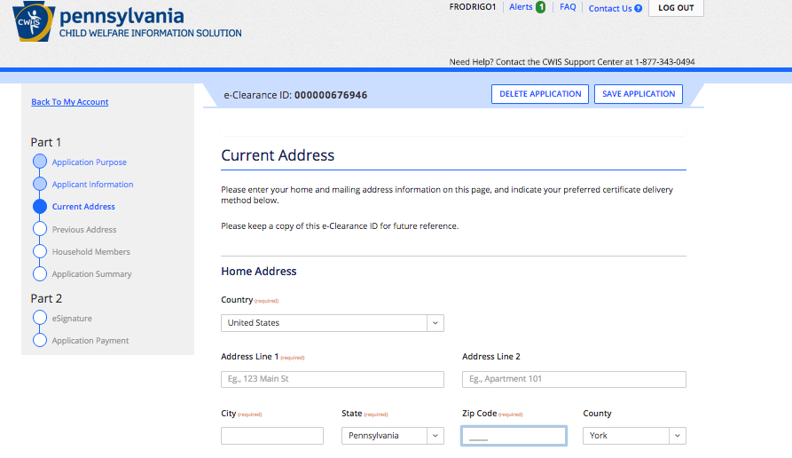

Then check whether your mailing address is the same as your current address.

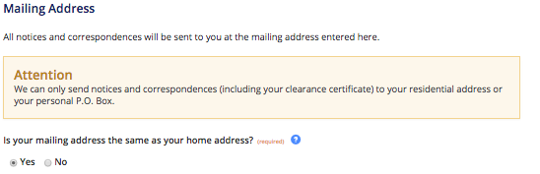

If it is, continue on. I

f not, enter your

mailing address

information when prompted.

24) Next, check whether or not you would like a paper copy sent to you.

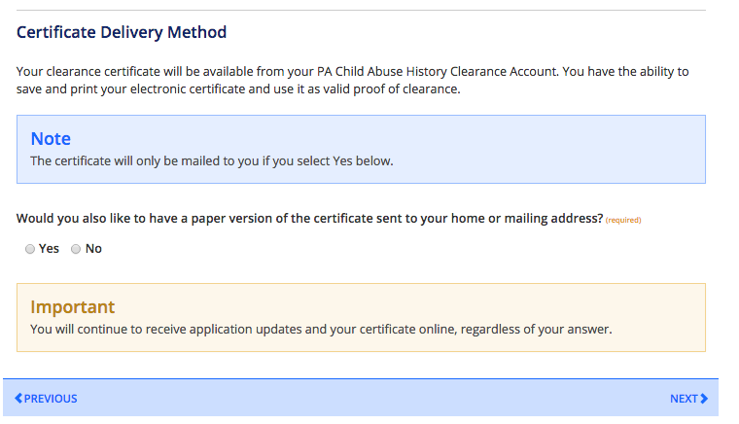If you would like to have a

paper copy sent

to you besides the

copy you print today,

check this box “Yes”

Then click “NEXT”

25) Now you will be prompted to enter your previous address information. **Enter all of your previous addresses since 1975.**

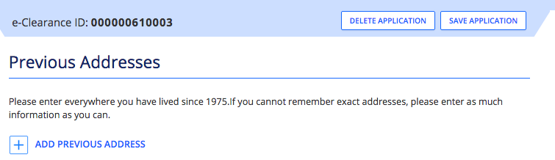

**Click on the “+”**

Now you will be prompted to enter previous address information.

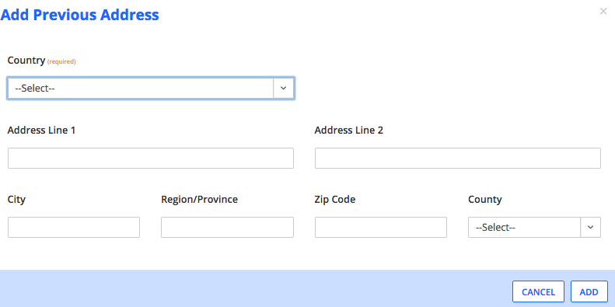

Once you enter your information for the first address, click “ADD”

**Continue to click the “+” and add addresses until you have entered all the information since 1975.**

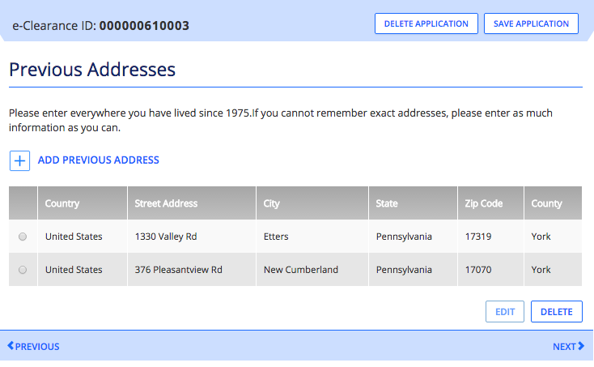

Then review your information

and click “NEXT.” If the

information is not correct,

hit “EDIT” to change it, or

“DELETE” to delete it.

26) Now you will need to add your household member information. **Enter names of people you have lived with since 1975- parents, siblings, spouses, etc.**

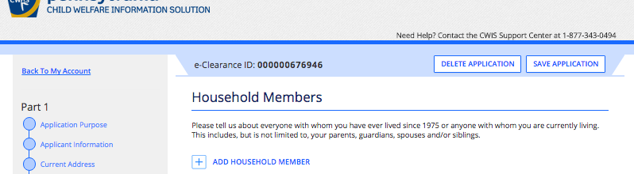

Click on the “+”

to add names.

27) Add your household members since 1975.

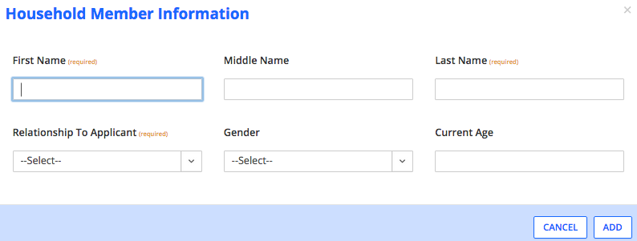

Then click “ADD”

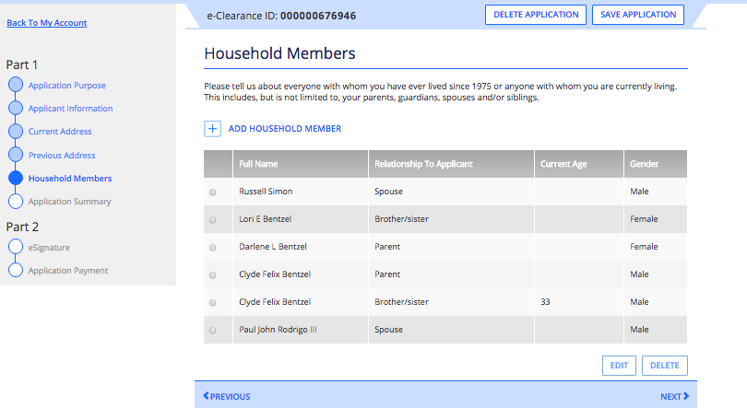

Review your information and click “NEXT”

27) **YOU ARE ALMOST FINISHED!!!** Review your application summary. Make sure all the information on this page is correct!

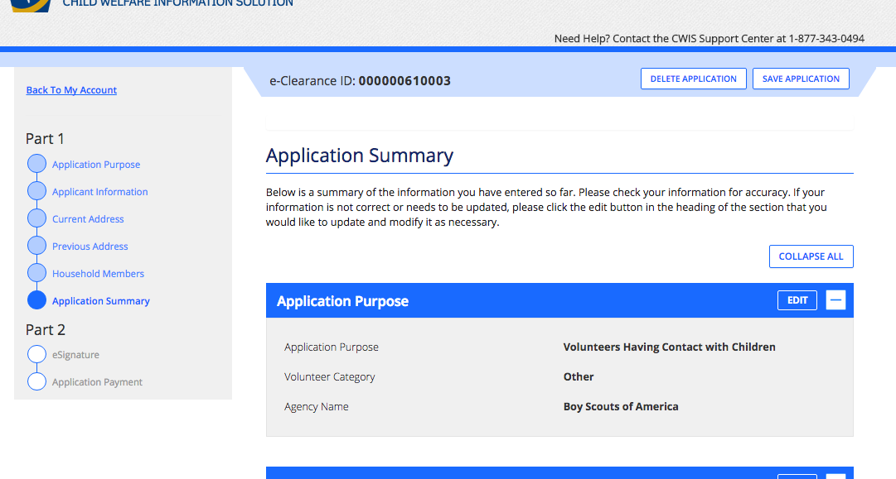

Then click next at the bottom of the page.

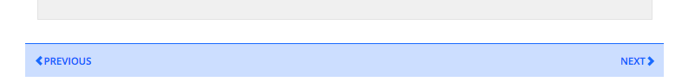

28) You will need to type in an “E-Signature”.

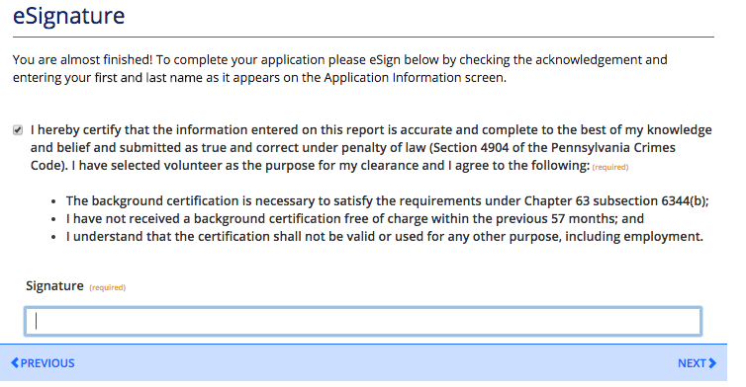

Check the box to

verify the

information

you provided is Then click “NEXT.”

correct.

All this means

Is you have

to type

your name

in the box..

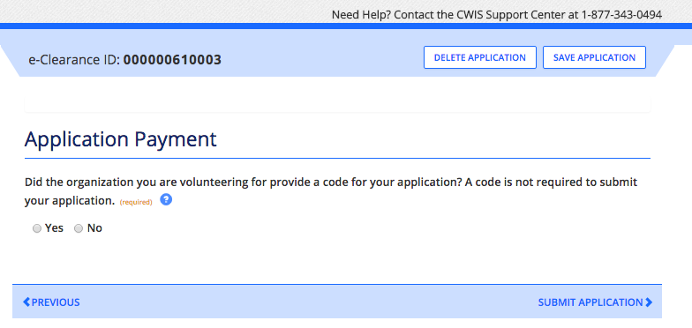29) Payment page:

Click whether or not

your organization gave

you a payment code.

Most organizations probably do

not have one, because its free now.

**Then click “SUBMIT APPLICATION”**

30) You will see the confirmation page.

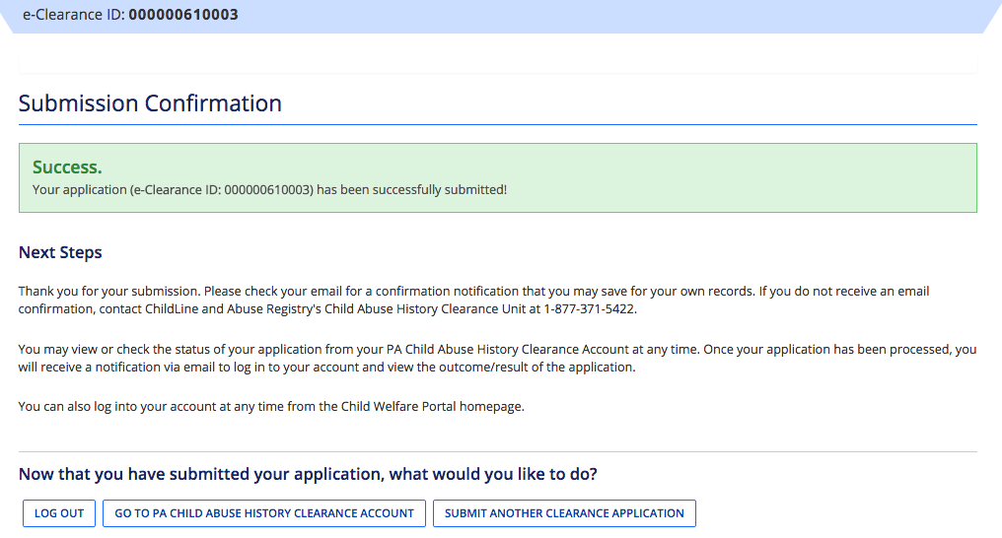

Click “LOG OUT”

31) Then go back to the website you entered in the beginning.

32) **Click individual log in** 33) **Click access my clearances**

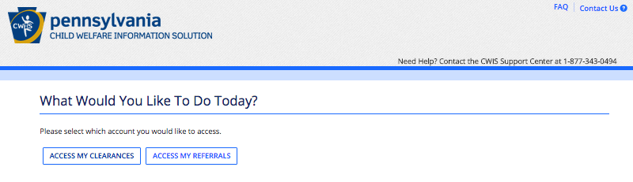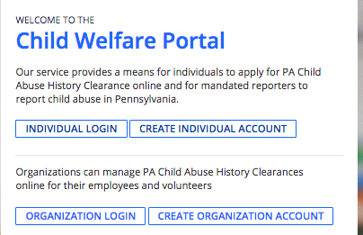

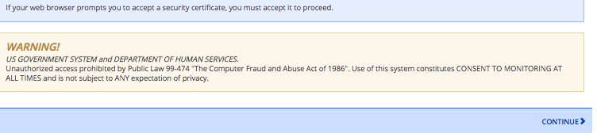34) **Click continue at the bottom of the next page.** 35) **Login in with the username and password you created in the beginning.**

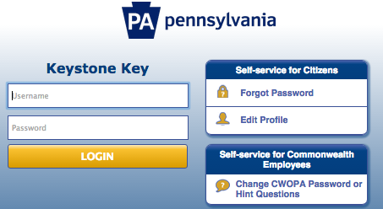

36) This is the last step.

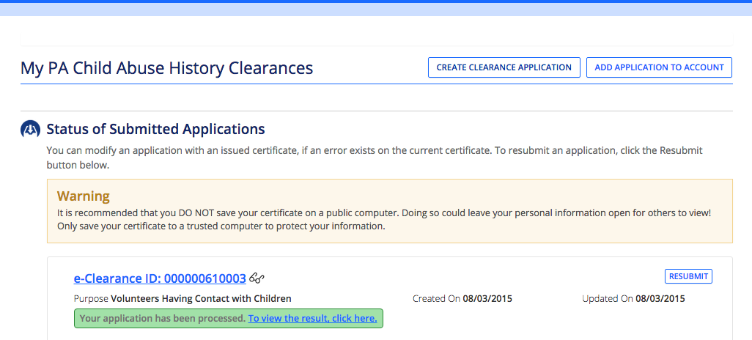

**Click on “to view the results, click here. Your certificate will pop up to print and/or save it on your computer for later. Print 2 copies, one for your records and one for the organization.**