**How do I apply for Pennsylvania State Police Clearance On-line?**

There are two sets of clearances required as a volunteer. These instructions will help you apply for both of them.

I. Pennsylvania State Police Clearances On-line:

1) Type the state police web link into your web browser: <https://epatch.state.pa.us/Home.jsp>

2) The screen you come to will look like this:

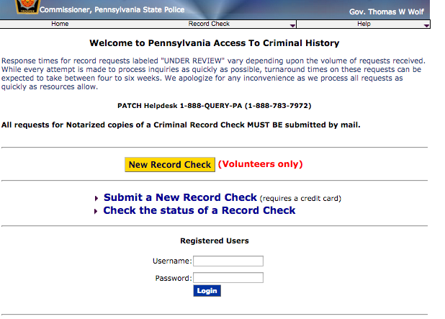

Click on the Yellow box that says

“New Record of a Record Check”

3) The next screen you see will look like this:

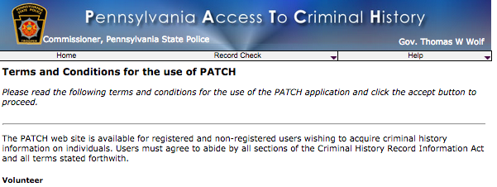Read through the terms and conditions. If you agree to the terms and conditions, scroll to the bottom of the screen.

**Take note to the possible results:**

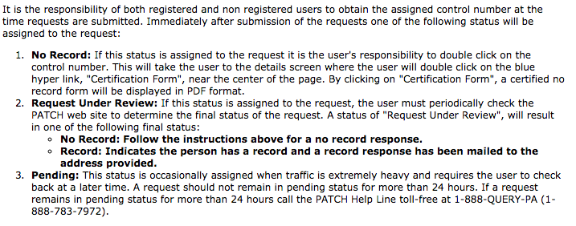

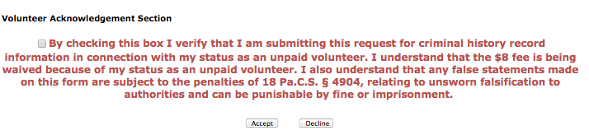4) At the bottom of the page you will see red print with a box beside it.

**Click on the box** and little mark will

appear inside so you know it is checked.

This will ensure you do not have to pay for your clearances. Then **click on the box** that says **“Accept”**

5) Immediately you will be taken to the next page.

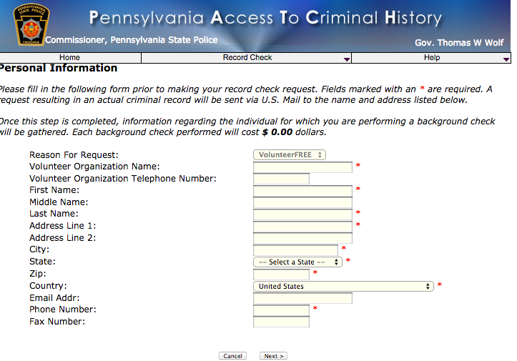Insert your information in the boxes.

You want to keep “VolunteerFREE”

Type in **“Good Sheperd**

**Lutheran Church”** as the “Volunteer Organization Name””

Complete the rest of the sheet with your information. Then click on the “Next” button at the bottom of the page.

6) The next screen will show you all of the information you entered. Check to see if it is correct.

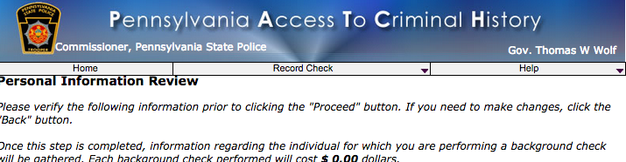

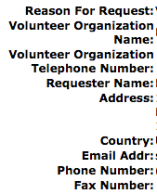

Your information here.



Click “Proceed”

7) On the next page you will have to enter your personal information. You do not have to provide your social security number, but it will make the process a lot easier. **No one will have access to you social security number except the government who issued it!**

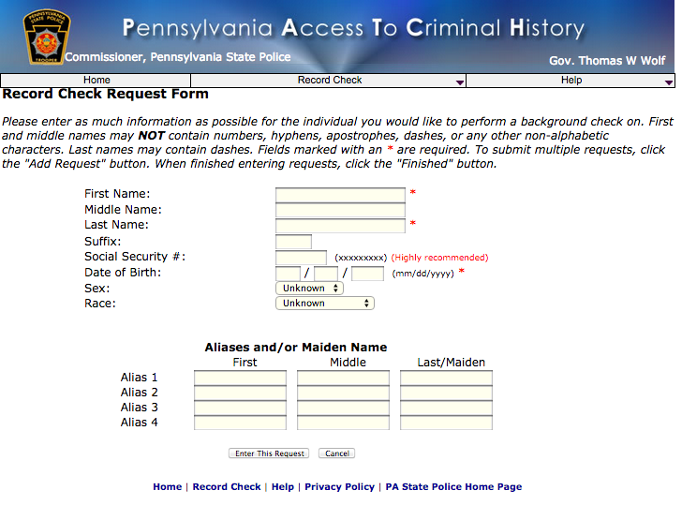

If you have Aliases, or Maiden names, enter all the previous names you have had.

Then click “Enter this Request”

8) The next screen will look the same. But, at the bottom it will have a new set of options. If you are entering a request for yourself and someone else, you can enter the other person’s information into this screen.



When you are finished entering all information for all requests, **Click “Finished”**

9) The next screen will display your information ready to be submitted.

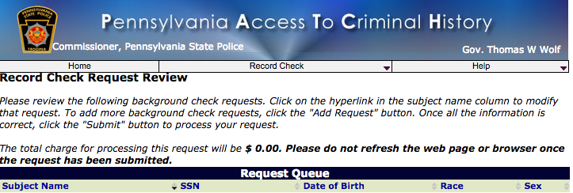



**Click “Submit”**

10) The next page will give you your results and a control number.

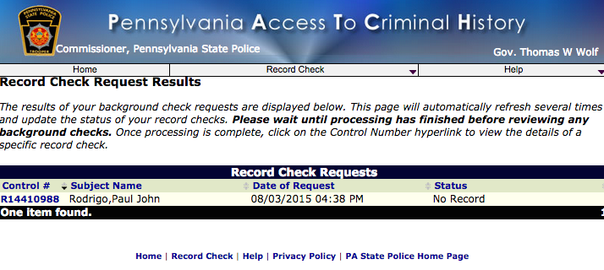

**Click on the blue control number to view your official certificate. There are only two more steps.**

11) The next page will have blue words at the bottom that say **“Certification Form”**

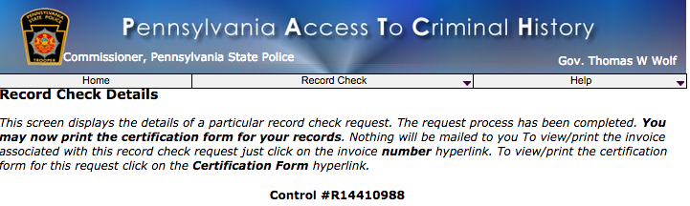

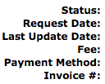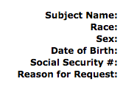



Click on **“Certification Form”**

12) This will show you your actual certification form.

At the top of the form you will see:



You should print at least 2 copies. One for yourself,

and one for the church or organization you are volunteering for. **Click print.**

**If you would like to save it to your computer to print copies later- click save.**

The document will download and appear at the bottom of your screen. You will need to click on it and hit save as. Save it to your computer.